Fun with Tableau_Basic

Rao Katie Xu

Environment: Win10 64 bit (Parallel Desktop on Mac OSX Yosemite 10.10.5 )

Tableau: <http://www.tableau.com/products/desktop/download>

*Project 1:*

Datasets: <https://www.superdatascience.com/tableau/>

Download: SuperStoreUS_2015.xlsx

Aim: To find less profit and most profit state and create the state performance

Double Click the SuperStoreUS_2015.xlsx

Drag the orders to the “Drag sheets here” area, the detailed data will show up.

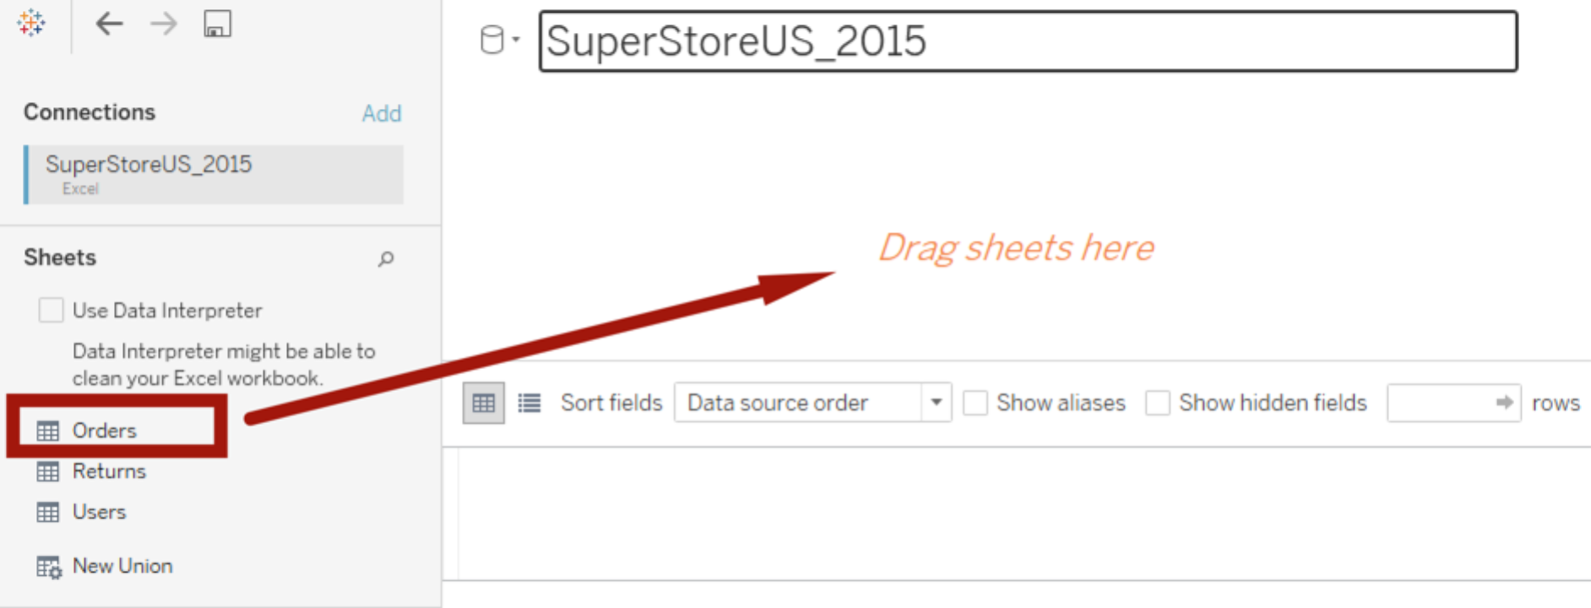

Click the “sheet1” down left the corner, then drag the Country to the right Sheet1 area

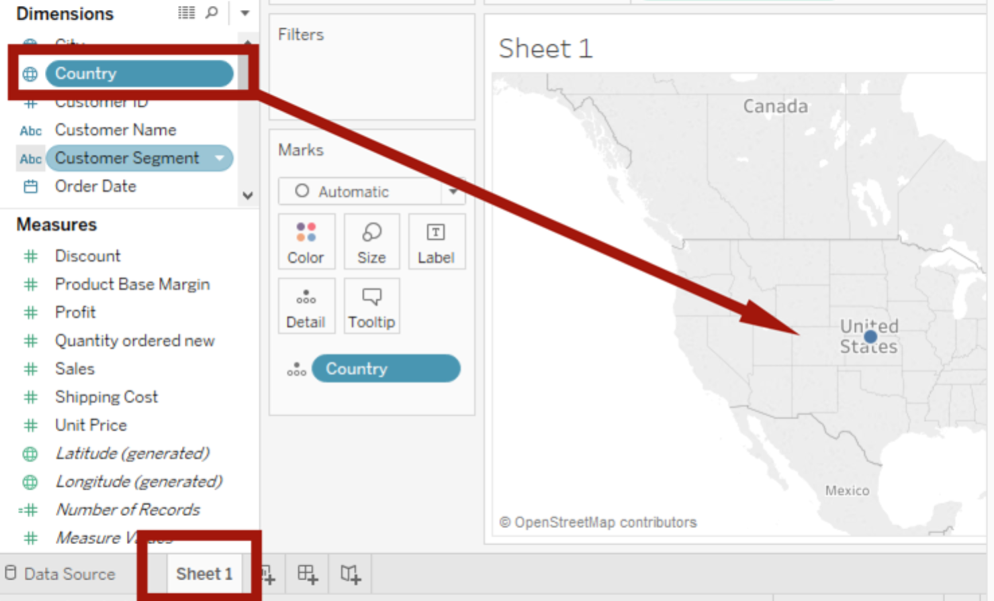

The drag the State or Province to the map, then the map will show blue dots.

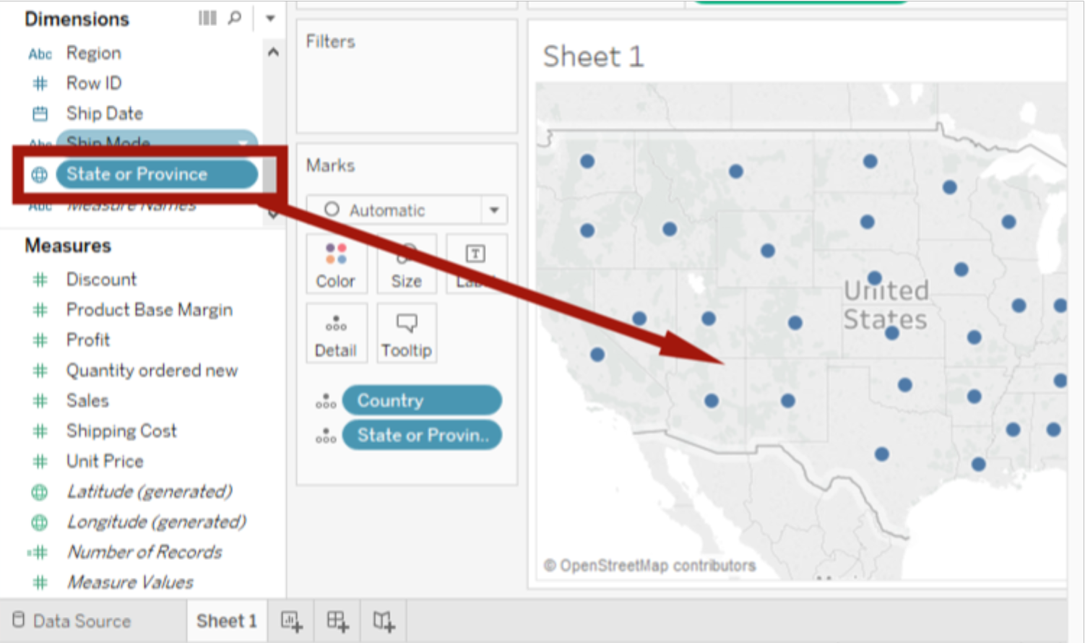

Drag Profit to the Automatic->Color and Automatic ->Label, we can see the US map covered with color and the profit number. Now we can tell orange means less profit and NC has the least profit with -$19,428, and CA has the most profit with $37,432.

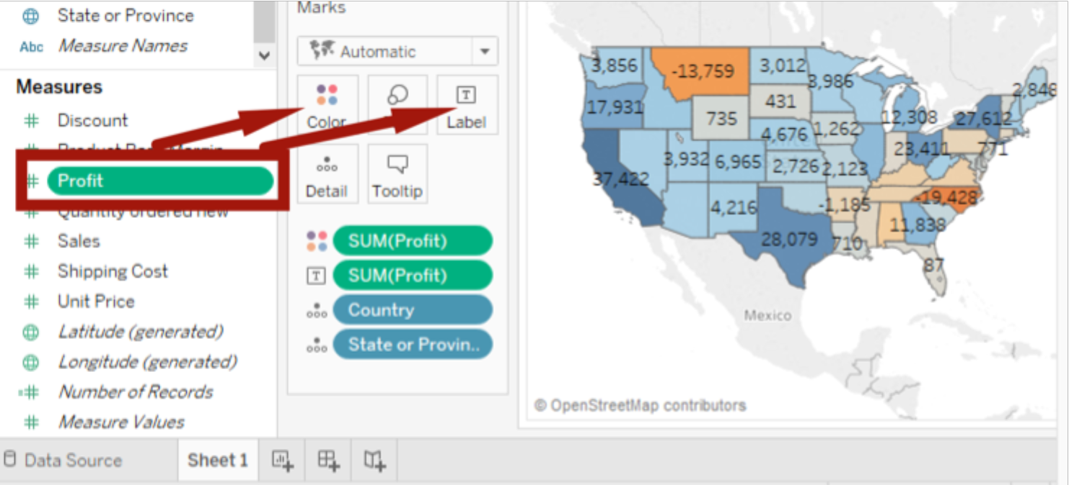

*Project 2:*

It’s EOFY (aka End of Financial Year) and that means time for annual bonuses!

The store operates in three regions and only the top-performing employee in each region qualifies for a bonus. Find out which three employees are eligible to get bonuses for this year.

Employees are measured on total sales ($$).

Datasets: <https://www.superdatascience.com/tableau/>

Download: OfficeSupplies.csv

csv file is actually text file, so choose open->text File, and open OfficeSupplies.csv file

on the sheet1 label, drag Rep to Columns, drag Units to Rows, now we can see the bar graph, so we know Richard has the best sales.

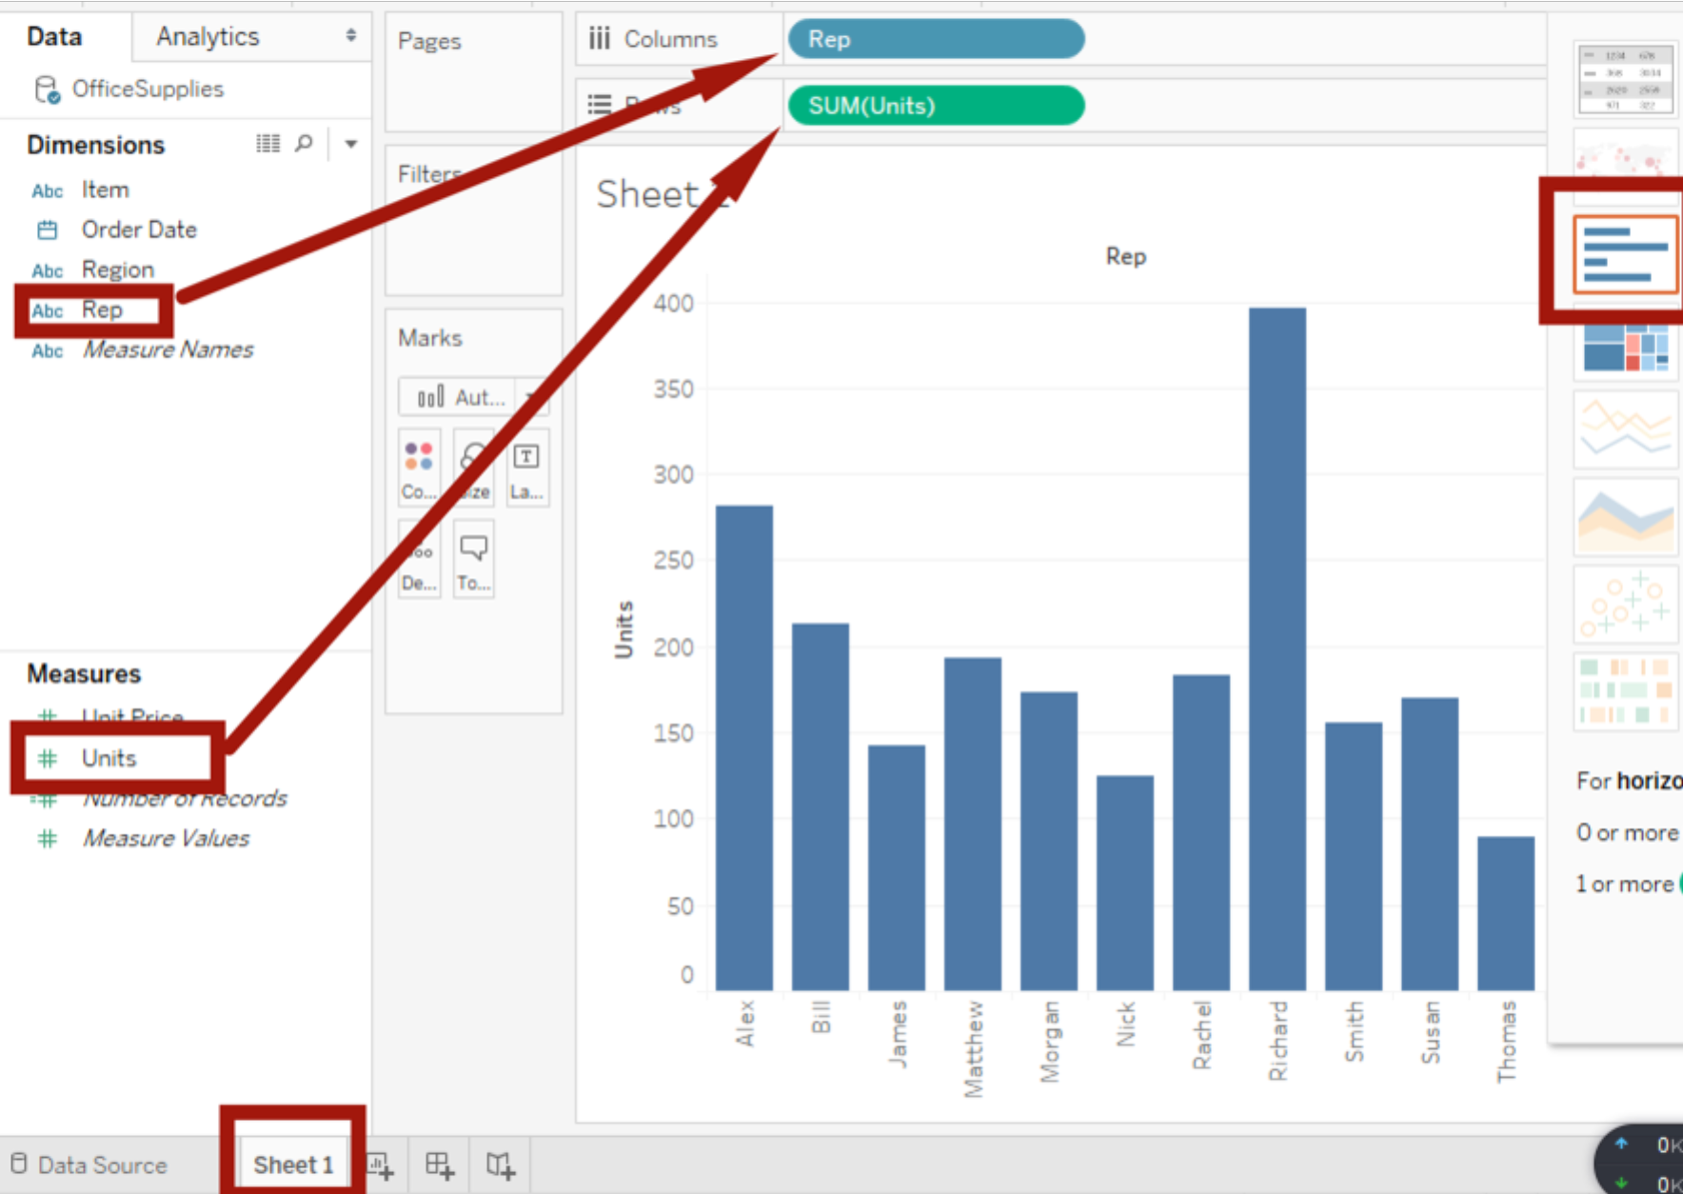

Now we drag Region and drop before the Rep on Columns. Now on the top of bar graph, it shows the region.

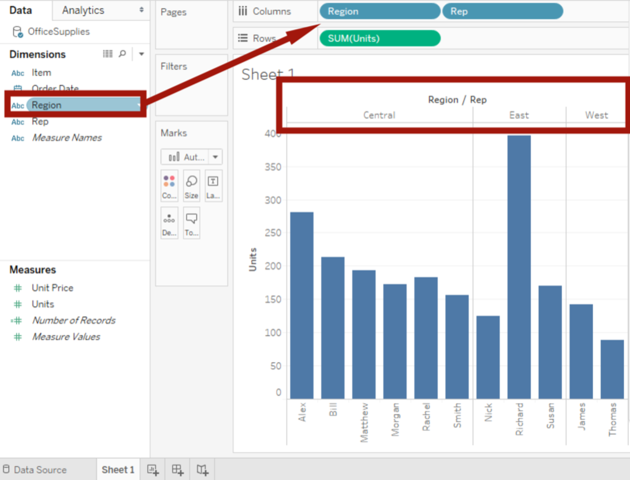

If we click the Units on the y-axis label, you will find the bar has been sorted.

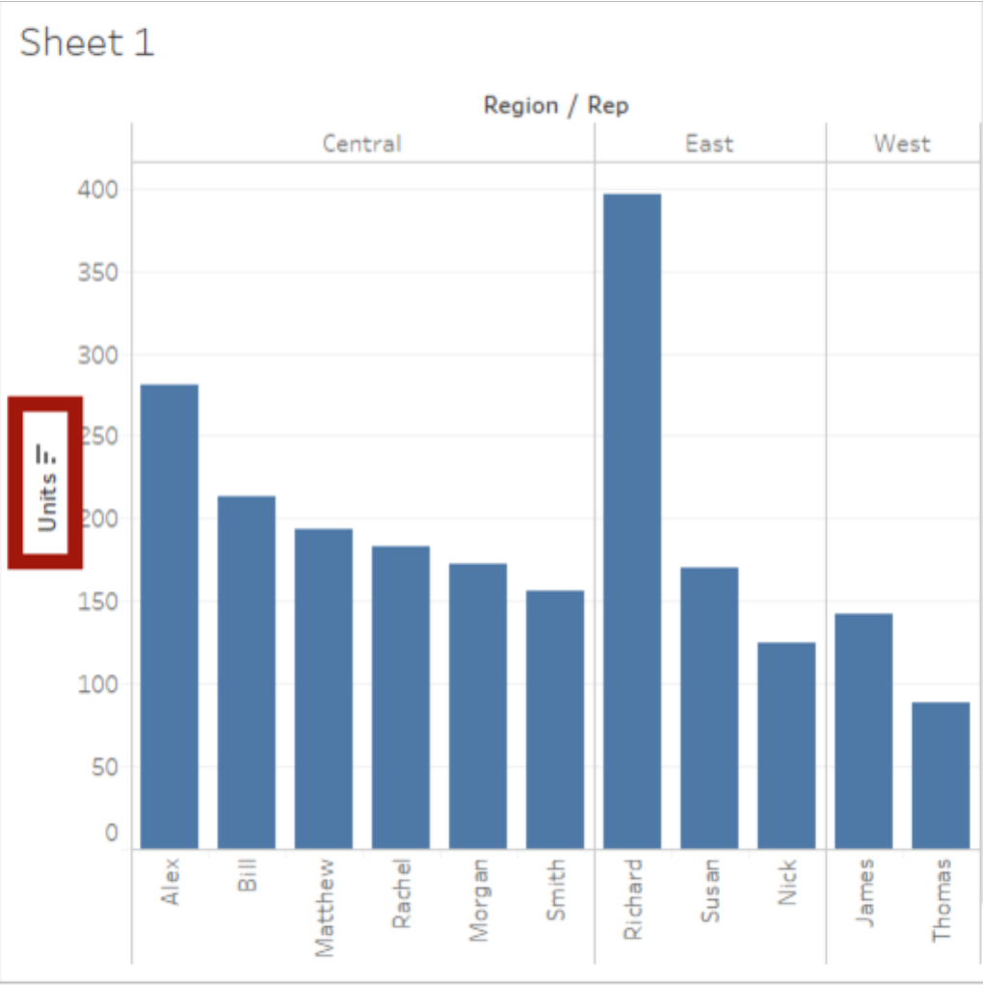

However, we need the total sales ($)= Unit Price * Units which is not in the table, then how to calculate in the tableau? First, we try to open the data file by right click the OfficeSupplies->View Data to open the data file. Yes, there are no total sales. Then we need to calculate.

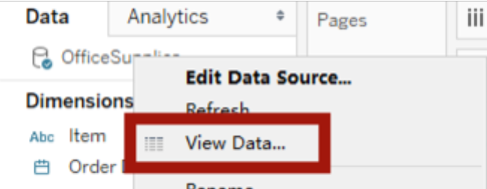

Right click the Measure panel, choose Create Calculated Field, and put TotalSales in the Text Box, and put Units * Unit Price, click OK.

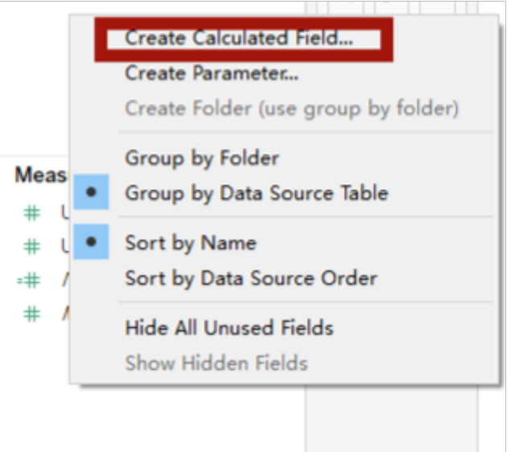

Then we will find in Measures panel, # TotalSales shows up.

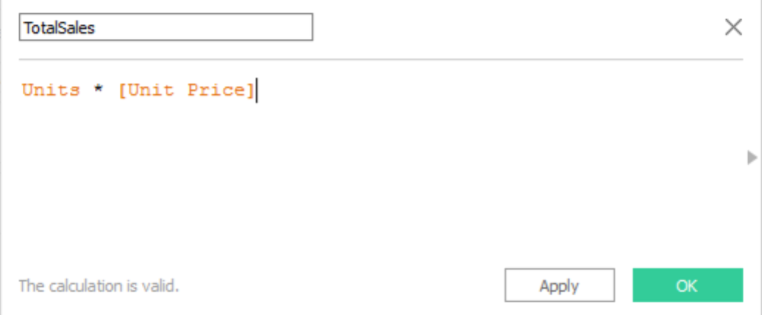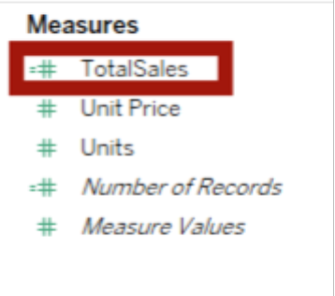

Then delete SUM(Units), and drag TotalSales int Rows, we will see the graph changed.

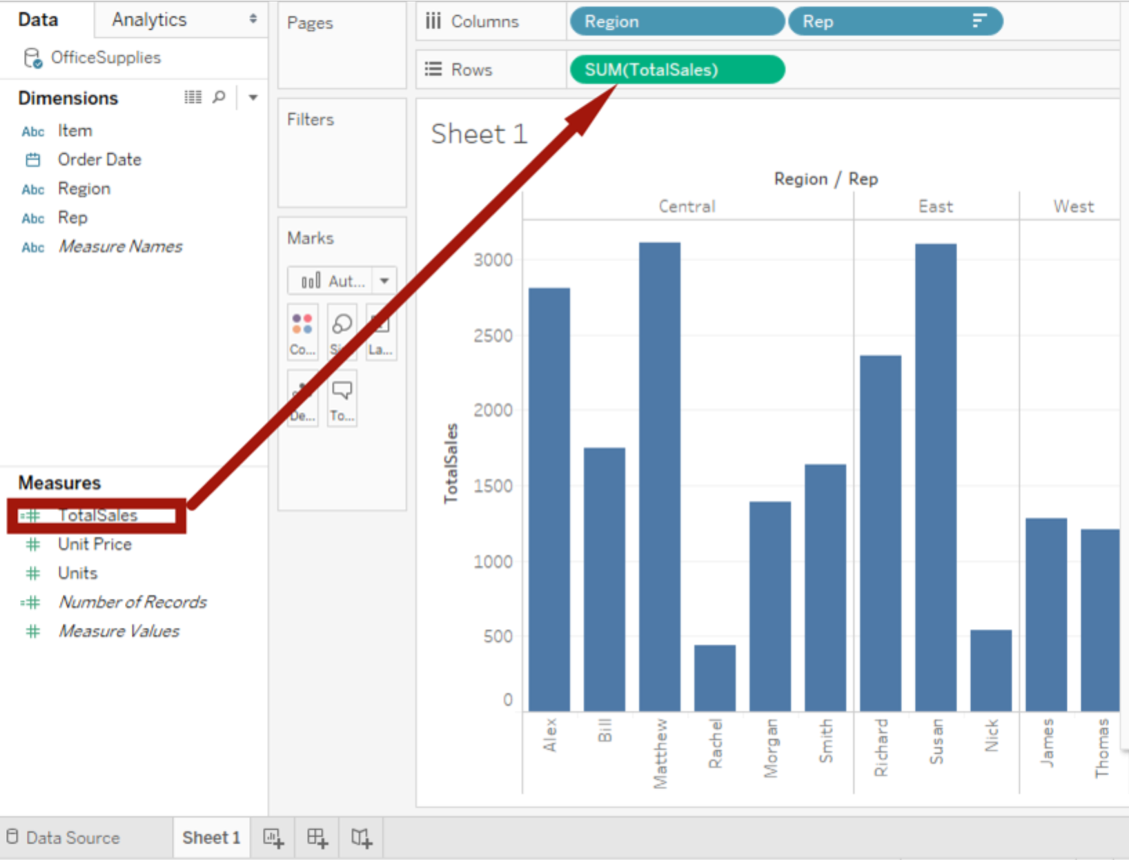

Sort TotalSales by click the y-axis label.

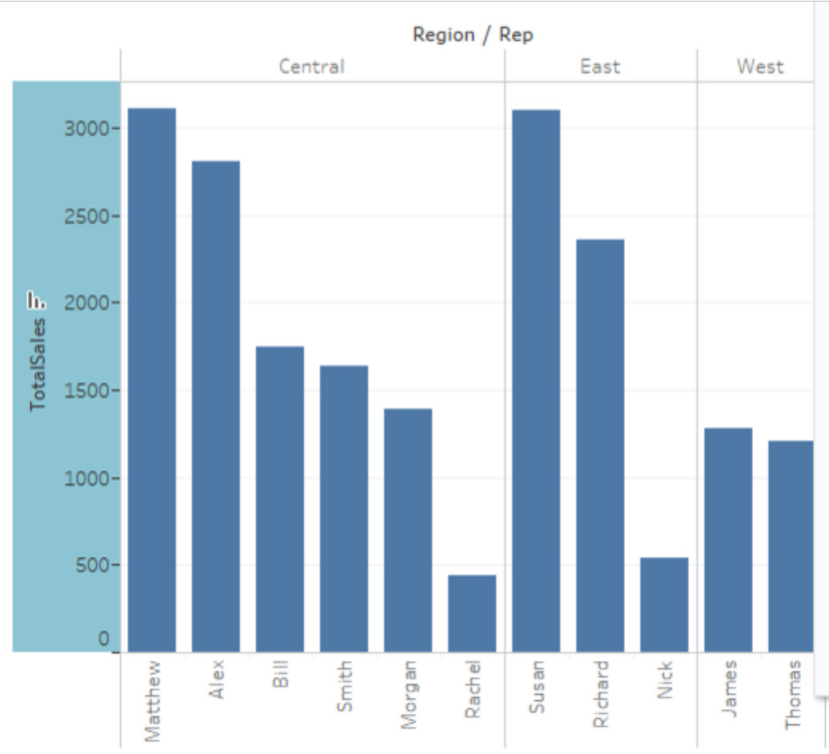

From the graph, we can tell in Central area, Mathew has the best sales, East area is Susan, West is James. Now we try to make the graph more colorful. Press Ctrl when drag Rep to left Color panel. Now it is prettier. (If not press Ctrl, the bar will become another bar graph)

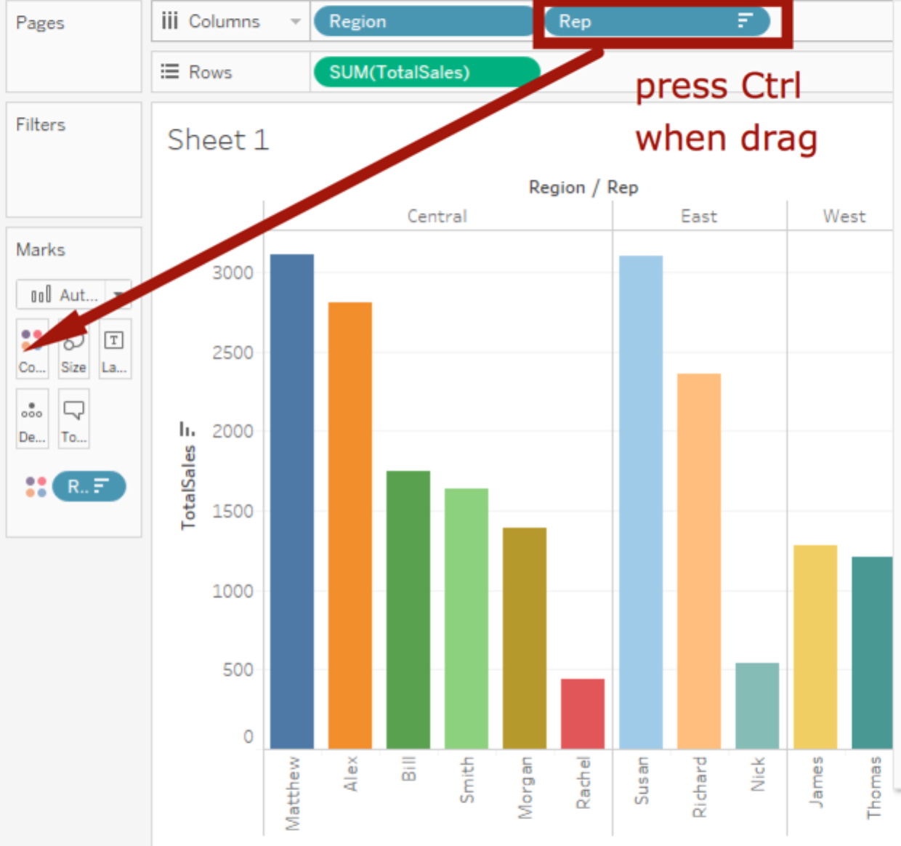

Now try to make region colorful. How to see the sales number? Now need to add labels and details. Click Label, the sales number will show on the top, also, we can drag Rep and Region from Dimensions Panel to the Label, we can see TotalSales, Rep name and region name are all on the top. Here the bar is too small so it won’t show all the data detail.

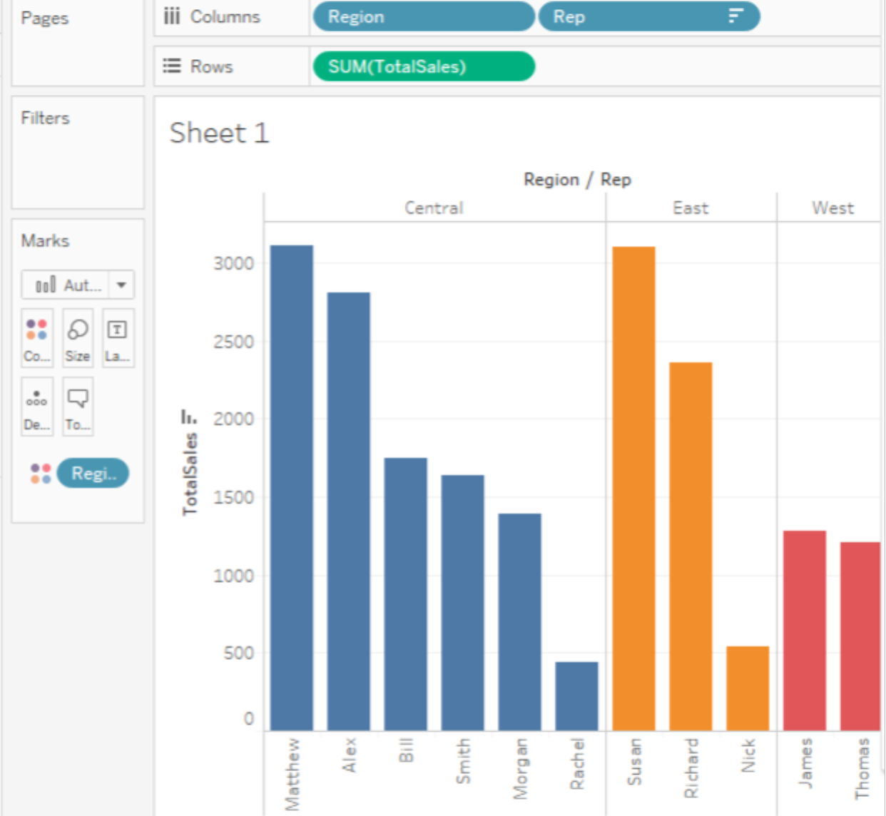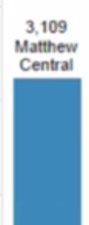

But we want to add $ before the number, right click Marks panel->Region, choose Format, a new panel will show on the left with all formatting. Click the Rows->SUM(TotalSales), then we can change Numbers to Currency, then $ shows up.

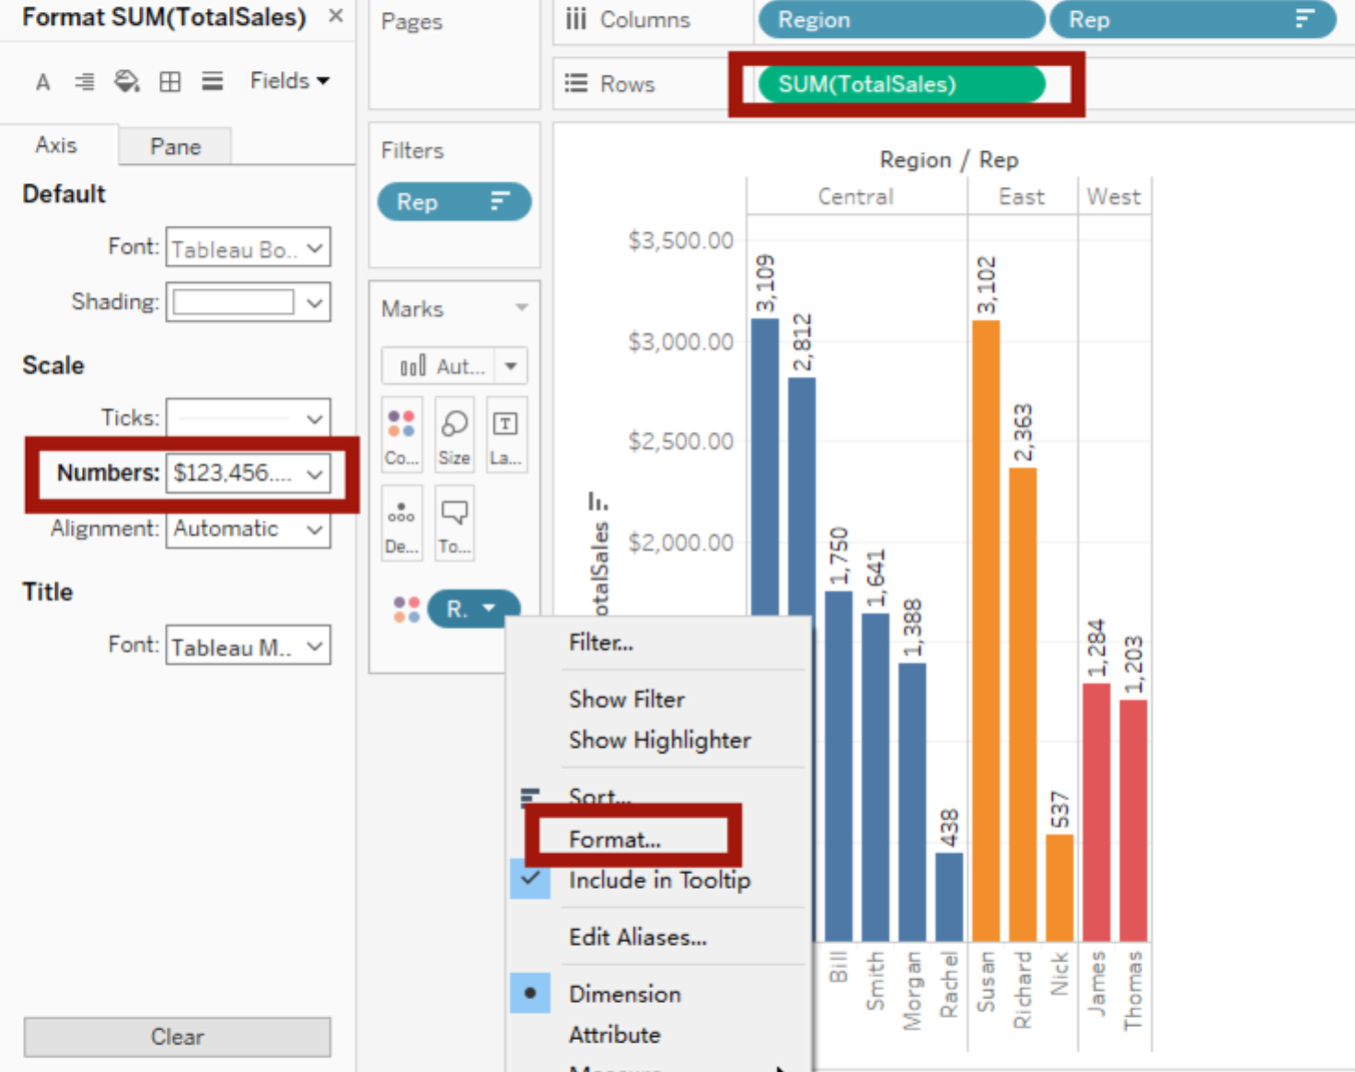

If choose Currency(Custom), we can adjust to UK or digits. Also, the formatting can help change word direction.

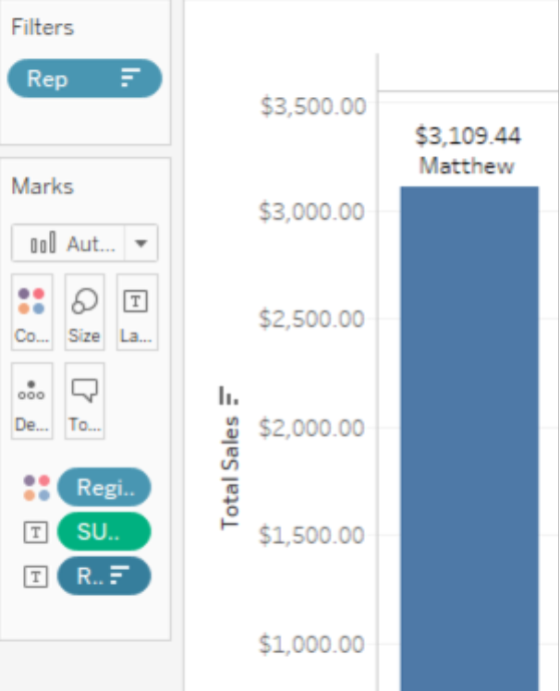

Now it is time to export the result.

Plan A: Worksheet->Export->Image

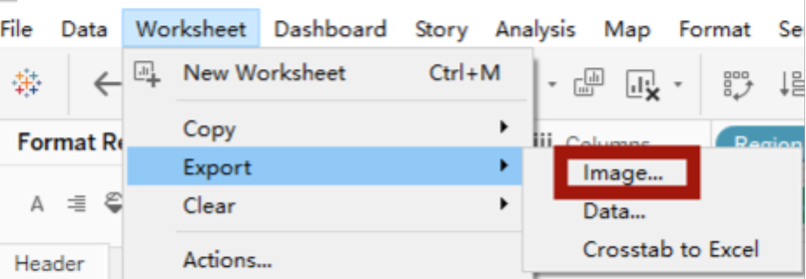

Plan B: right click the graph, Copy -> Image

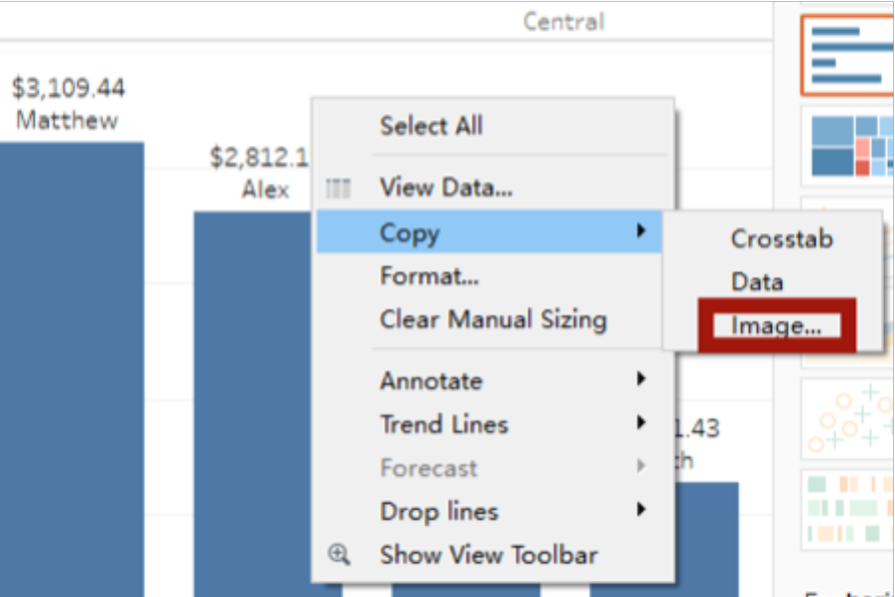

Once open a Word file, we can paste the image. However, we found sheet1 on the top, so we need to uncheck the Title when copying Image. Next, how to add the title?

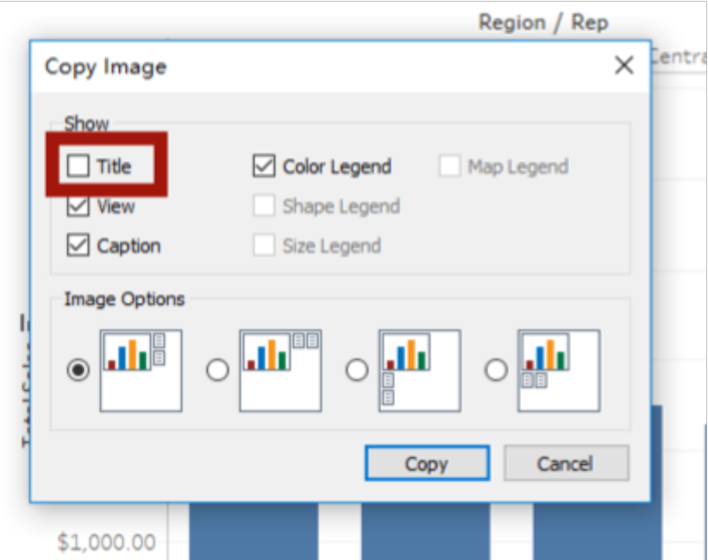

Go change sheet1 to Data Analysis, Worksheet -> Show Title, Check *Title* when copy Image, the image will have a title.

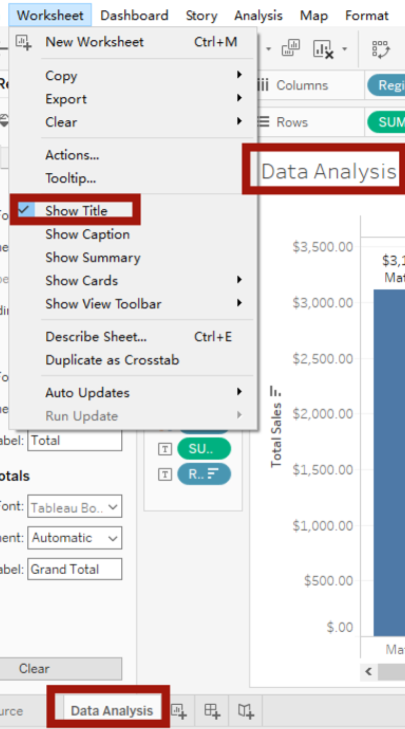

<http://public.tableau.com/profile/kirill.eremenko#!/>

for more tutorials.

Project 3:

Download: <https://www.superdatascience.com/tableau/>

Long Term Unemployment Statistics.xlsx

Drag Measures->Unemployed to Rows, drag Dimensions-> Period to Columns. Now we notice they are two-repeated Year/Quarter/Month/Day. What’s the difference? If you choose the first Month, then x-axis will show only Jan-Dec 12 spots, however, we want to show all 12 months in each year, then we need to choose the second Month. Now we have all the months.

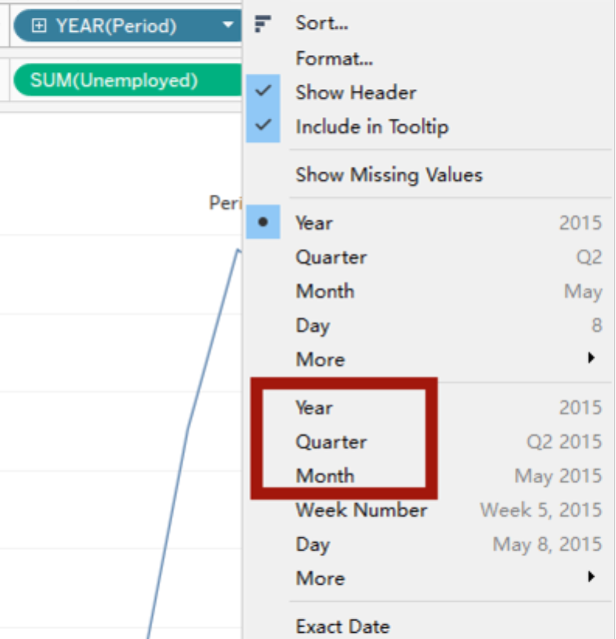 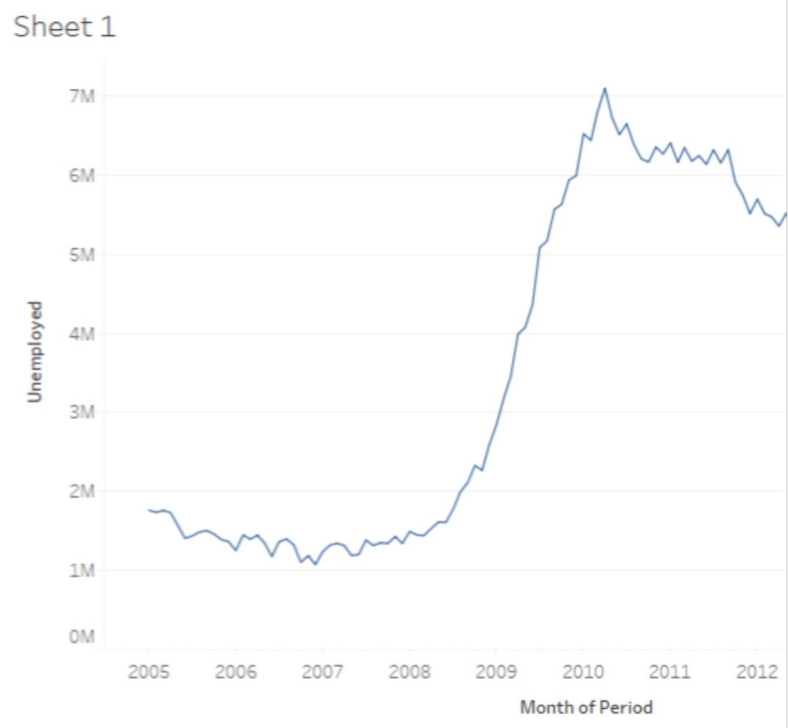

go search unemployed 27 weeks fred in st louis, <https://fred.stlouisfed.org/series/UEMP27OV>, it is very similar which means the data is real unemployed data.

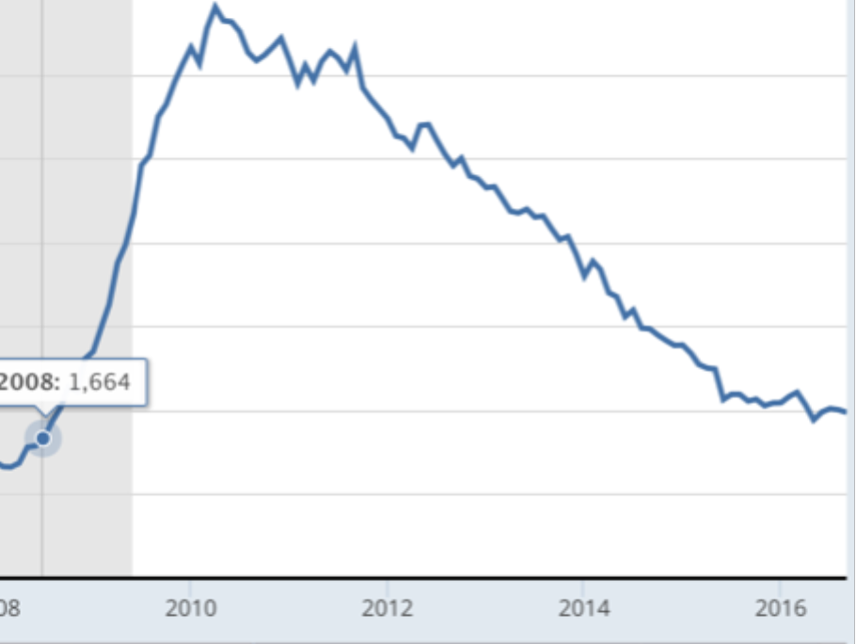

When choose the Marks->Shape, then the curve will change to dot, then adjust the size will change the circle’size.

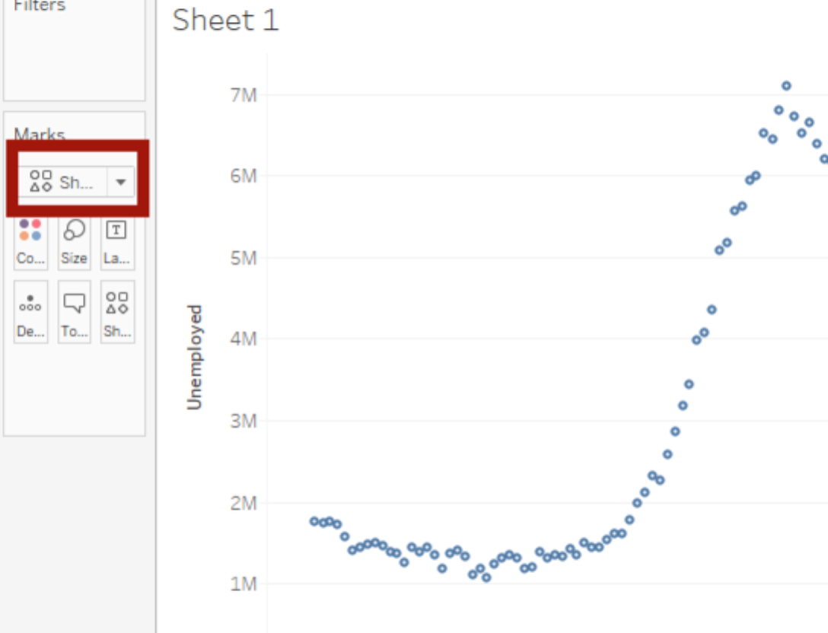

Then drag the Gender to the Color, we can see the gender data show up on the graph.

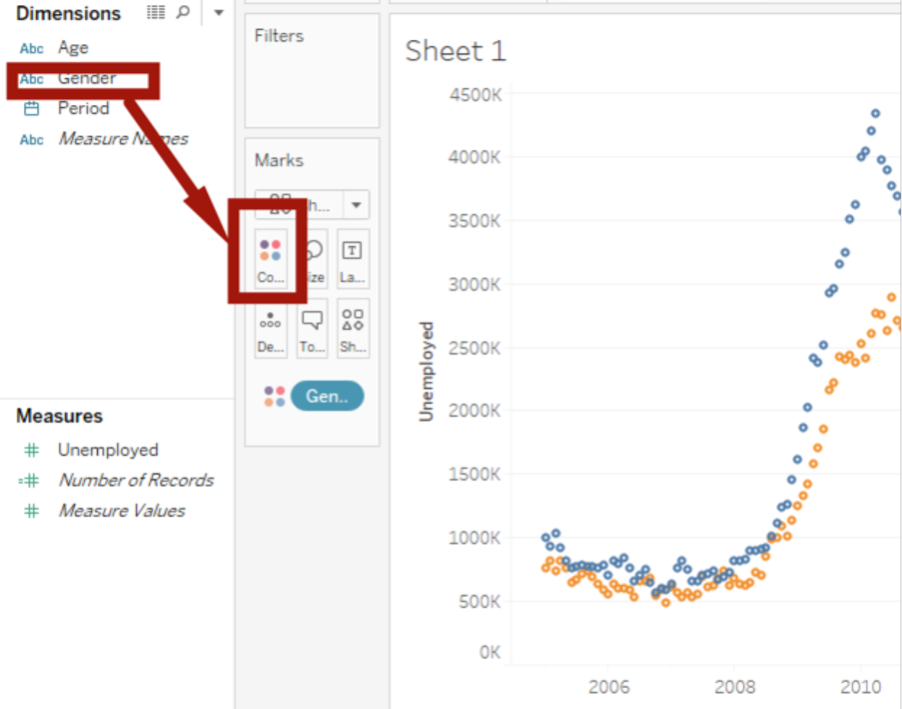

Then drag Age to the shape, we can see all different ages on the graph.

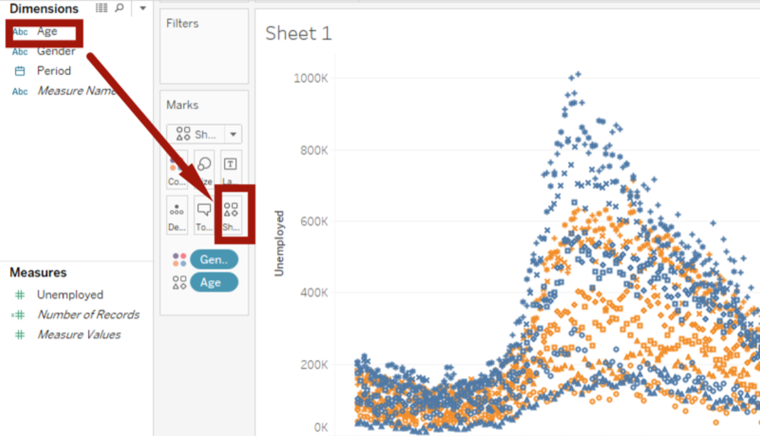

Now SUM(Unemployed) can do more than just Sum, such as Average, Median, Count

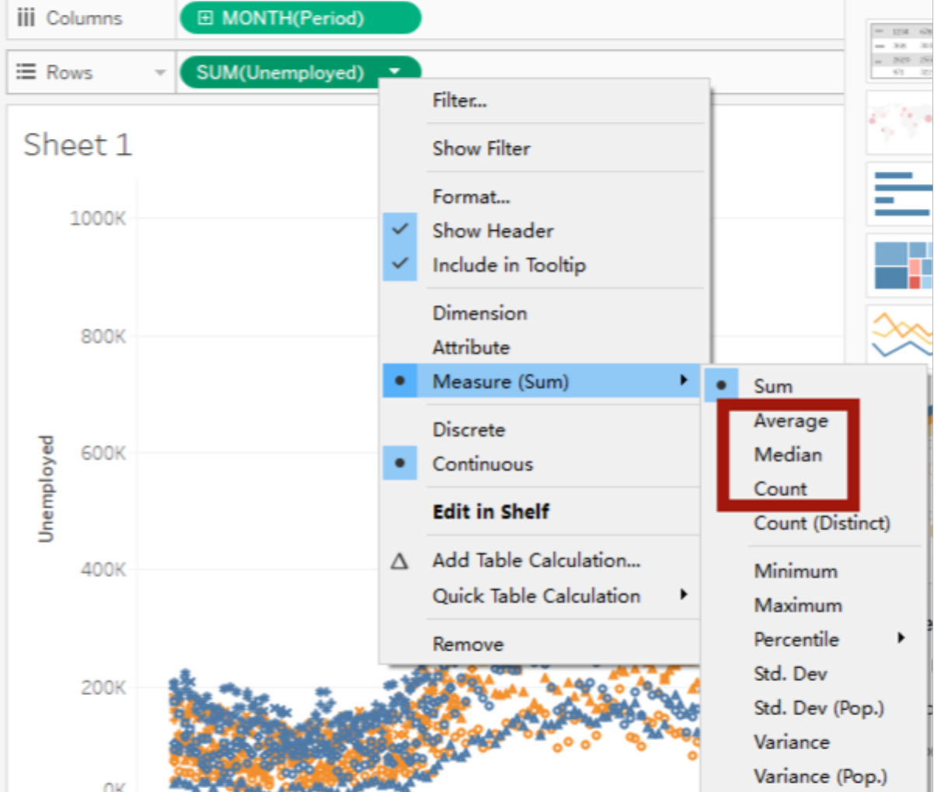

We can drag Gender to Details for aggregrations. Change graph to Area, when clicking the area, this area will be highlighted.

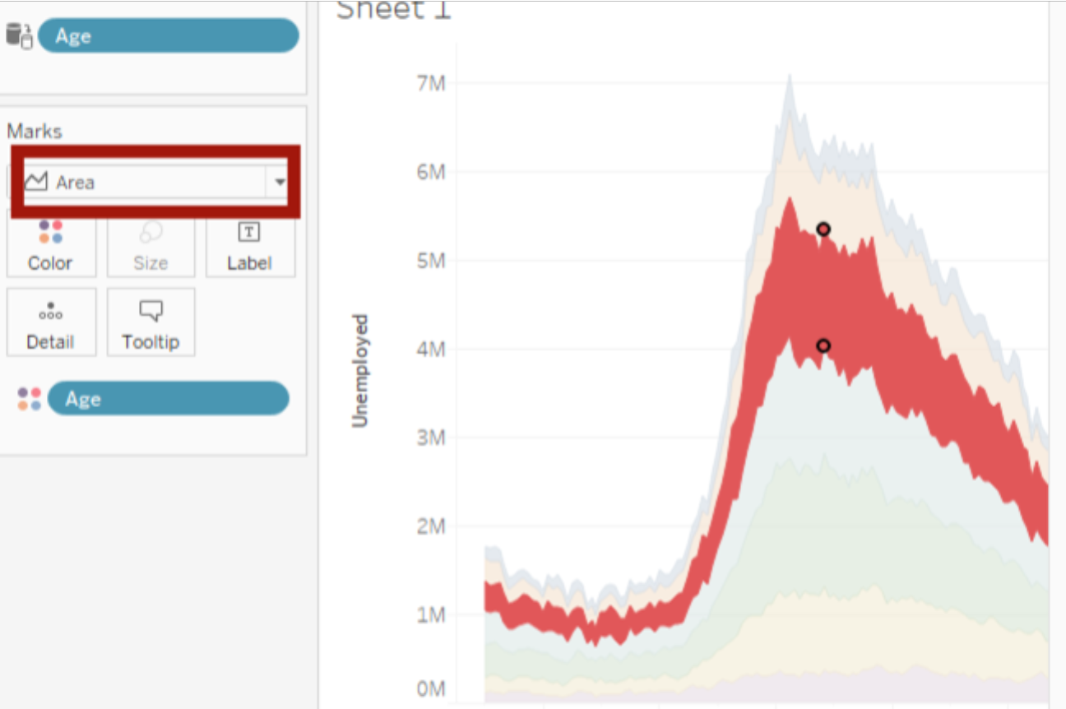

What if I only want to see the men’s data? Just drag the Gender to the Filters panel, a window will pop up, then choose Men.

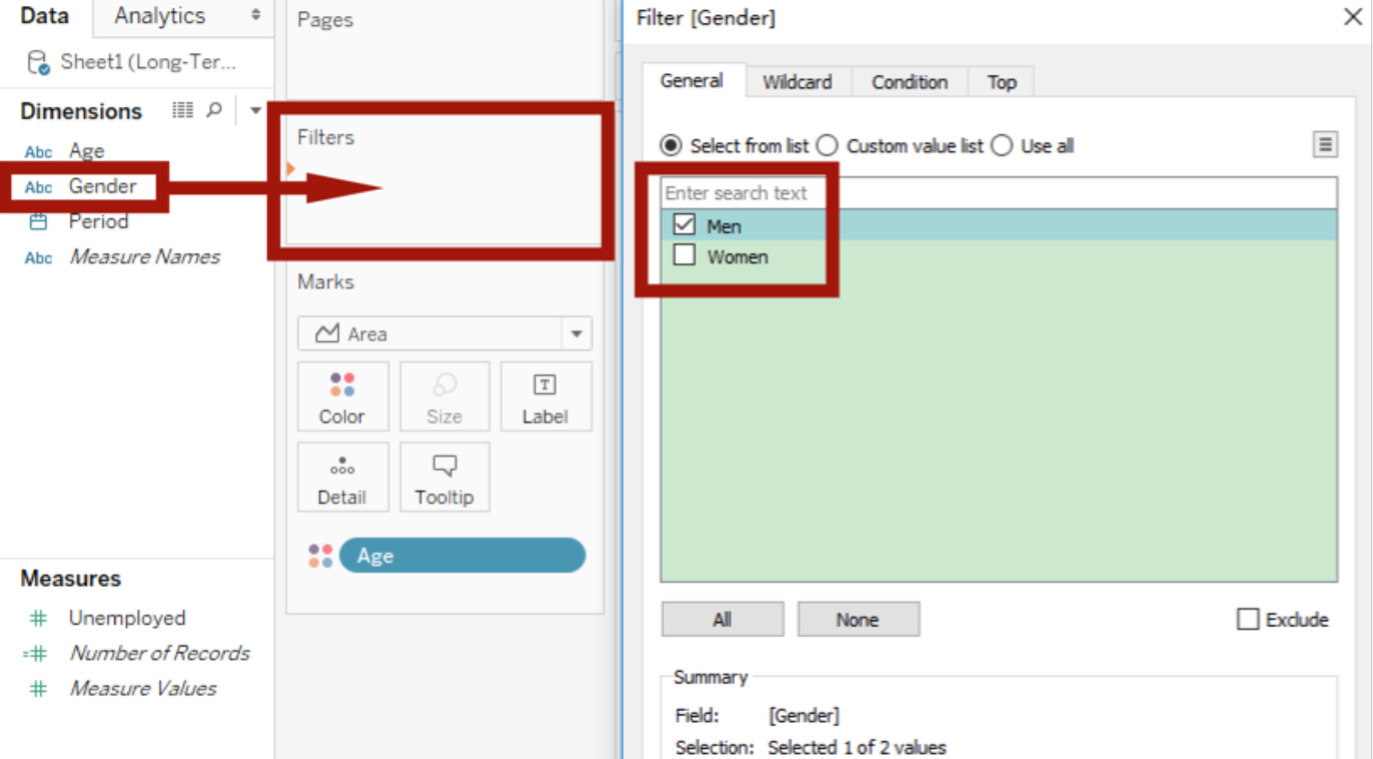

Now the graph only shows the men’s data.

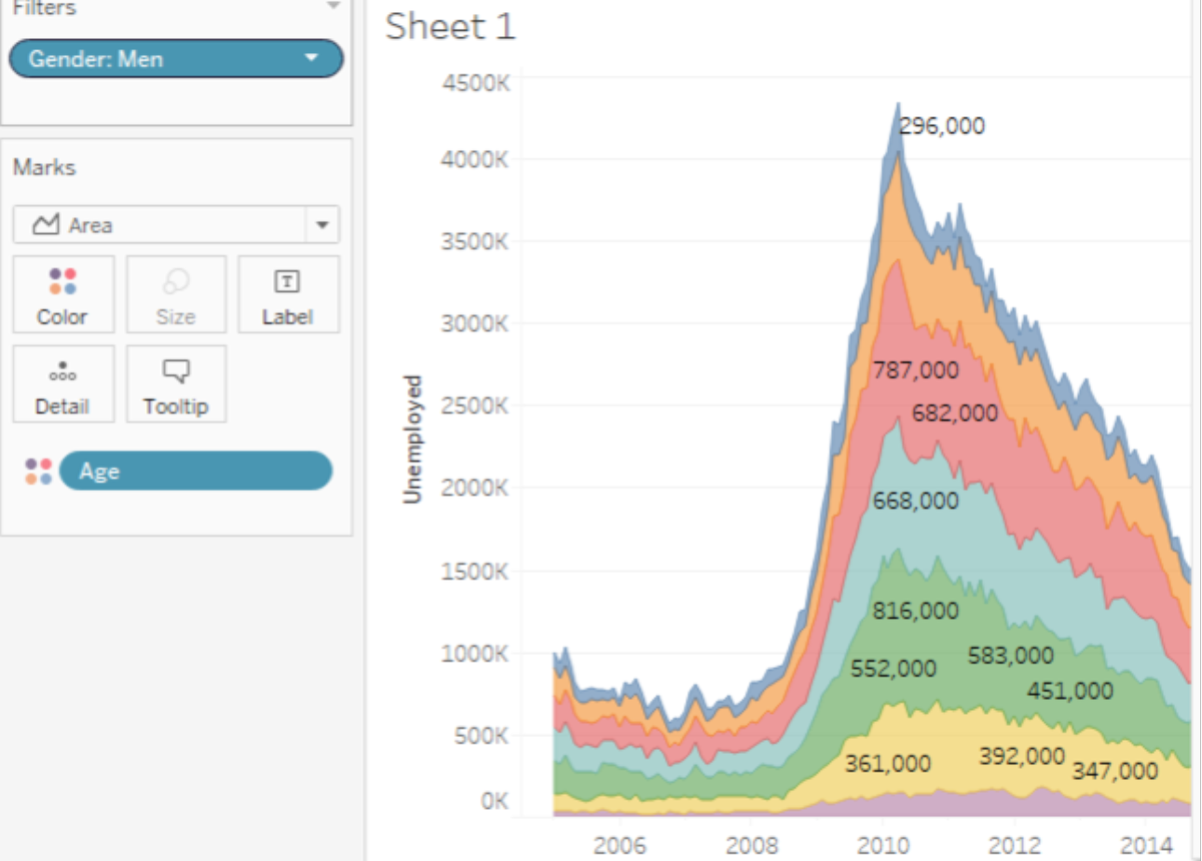

However, if there are so many data like age ranges. Is any way to be convenient? Yes. Right click the Age, choose Show Filter, then you can see a panel with different ages with colors. It’s originally hiding behind the Show me on the right side of the window. Just click the Show me, you can see the filter panels. Just check or uncheck the age ranges to find out the changes of the graph.

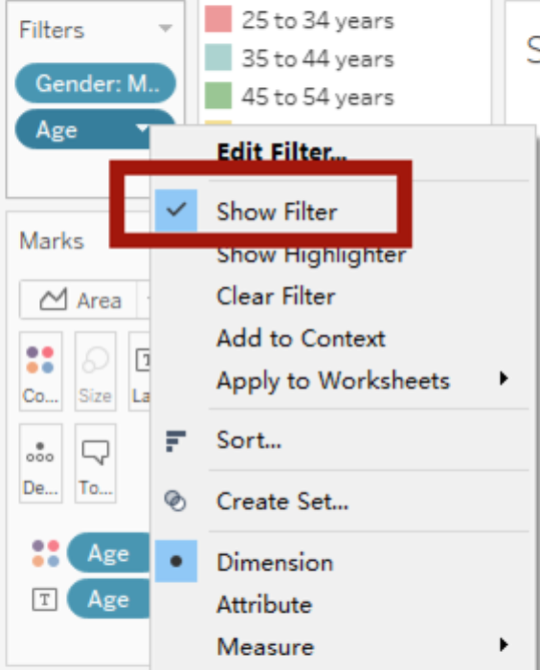

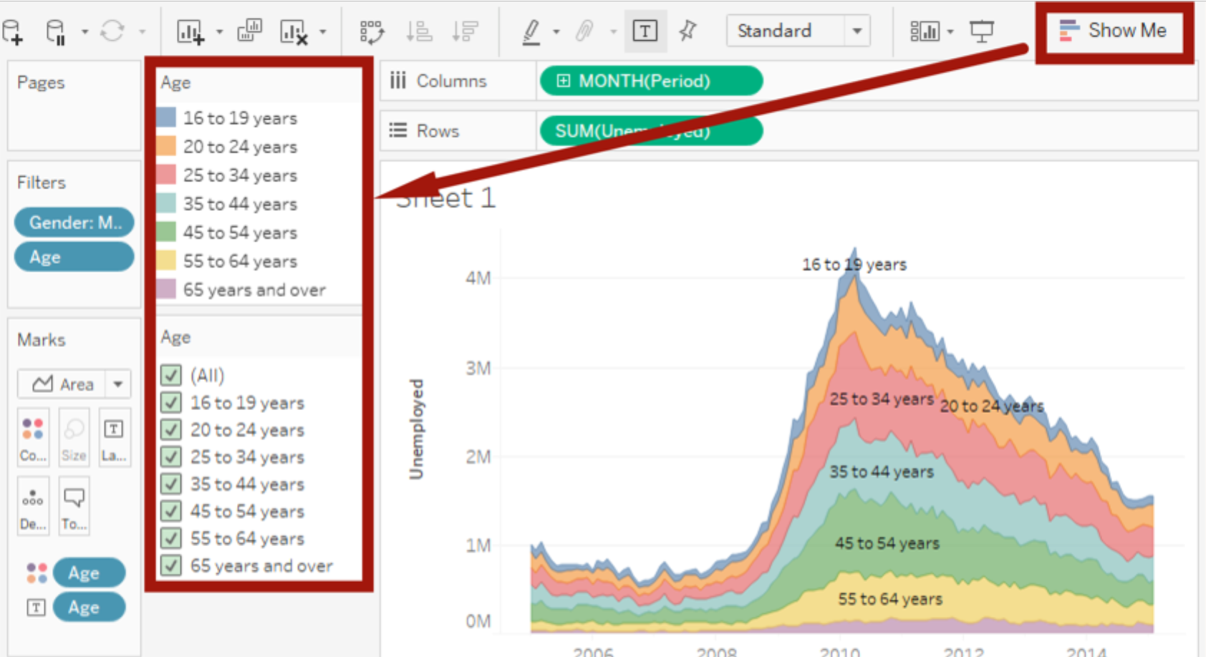

Which of these is a valid reason to use a Data Extract over a Live Connection to the Dataset in Tableau?

ANS: Your Data is constantly being updated and you want to work with a static file when building your visual (you will later return to the live connection when the visual is ready)

What is the difference between the Blue Month() and the Green Month() in Tableau?

Blue is a dimension and Green is a measure; Blue ignores higher periods such as year and treats month as a category - just like Gender; Green creates a proper timeline

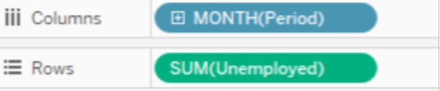 VS 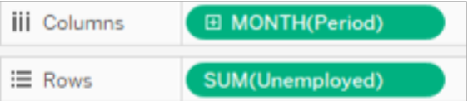

The Blue Month() is actually just treats month as a category.

Green Month() represents all months in each year(a timeline).

Measure vs Dimension: <http://www.evolytics.com/blog/tableau-fundamentals-dimension-vs-measure/>

*Generally, the measure is the number; the dimension is what you “slice and dice” the number by.*

